**Lecture Assignment – 2**

*Aryaman Gautam*

*J001*

1. A traffic signal has red which is on for 5 sec. In the last 2 sec we hear the buzzer with frequency of 440 Hz, followed by yellow light blinking 5 times which is on and off for 0.5 sec each followed by green which is on for 5 sec. At the last 2 sec of green, we hear a buzzer of 440 Hz frequency.

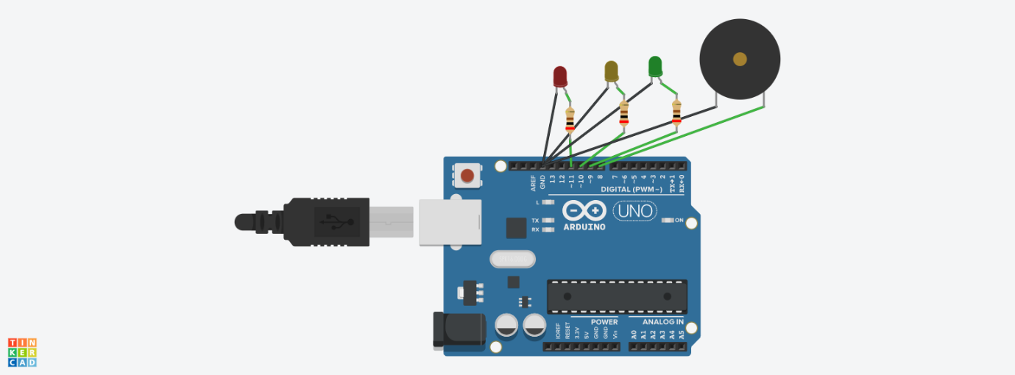

void setup()

{

pinMode(11, OUTPUT);//red

pinMode(10, OUTPUT);//yellow

pinMode(9, OUTPUT); //green

pinMode(8, OUTPUT); //buzzer

}

void loop()

{

digitalWrite(11, HIGH);

delay(3000);

tone(8,440);

delay(2000);

noTone(8);

digitalWrite(11,LOW);

for (int i=0; i<5; i++){

digitalWrite(10,HIGH);

delay(500);

digitalWrite(10,LOW);

delay(500);

}

digitalWrite(9,HIGH);

delay(3000);

tone(8,440);

delay(2000);

noTone(8);

digitalWrite(9,LOW);

}

2. Control the buzzer tone using Potentiometer.

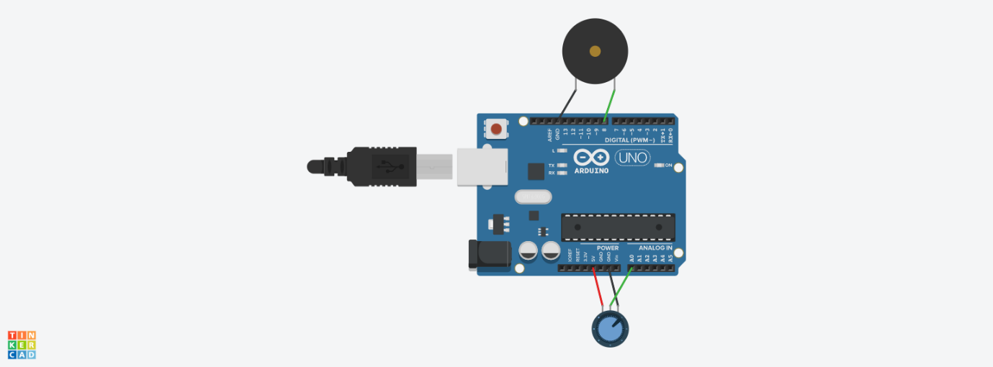

void setup()

{

pinMode(A0, INPUT);

pinMode(8, OUTPUT);

}

void loop()

{

int sensorValue = analogRead(A0);

tone(8, sensorValue);

}